Insight into Washington DC Airbnb listings
Report date: October 12, 2023

Consultant: Steven Broussard
Executive Summary
This report provides insights into Airbnb listings of the Washington DC market, spanning periods 2008 to 2023.
- The most expensive listing has a price of $1,228at Dupon Circle and cheapest listing has a price of $10 at Capitol Hill.
- The average price of all 1,1718 listings was $204.80, with 75% of all prices ranging from $125.00 (1st quartile) to $237 (3rd quartile).
- The # of accommodates per listing (maximum capacity of listing) is most highly correlated with price, as the larger the sq. footage and capacity available, the higher the price.
Key processing steps and assumptions:
 | Variable name | # of missing values | Method of replacing missing value (NA)
1 | Host acceptance rate | 222 | Mean of all existing values in column
2 | Room type | 15 | Changed NA to “Unknown” room type
3 | Bedroom | 261 | Replace with NA with the relative figures in Beds column
4 | Avg Rating | 12 | Mean of all existing values in column
To ensure completeness of population and that no missing values exists, the following processing steps were performed. I identified four variables (columns) with missing values, as listed below and utilized the following approaches to replaces the missing values:

1. Report your exploratory analysis of the data. This can include data visualization, summary tables, or any other insightful findings about the data.
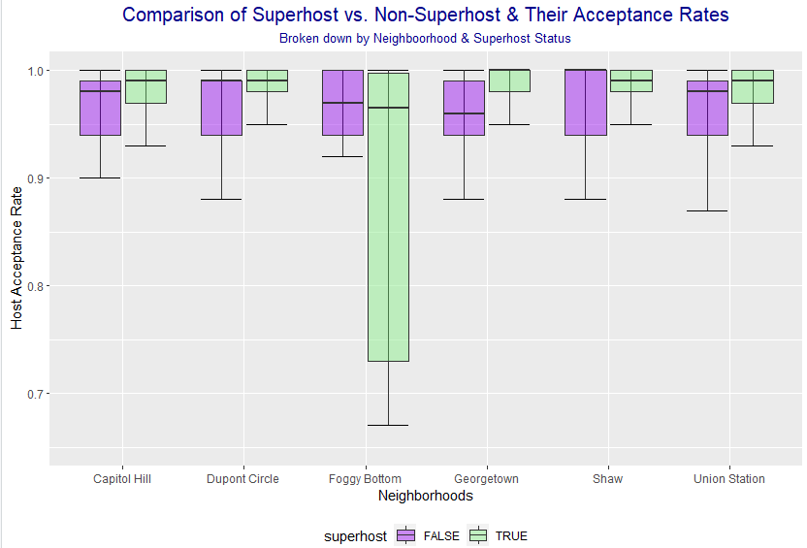
Population overview: I analyzed 1,718 unique Airbnb listings covering the months of Dec 2008 through May 2023, across six different neighborhoods in Washington DC, and found the following insightful information. I analyzed variability between super-host and non-super-host acceptance rate across each neighborhood. There were 985 non-superhost and 733 nonsuperhost listing properties:
- Figure 1 displays the host acceptance rate by neighborhood and whether the listing was by a super-host or not. The boxplot ranges from an acceptance rate between .65 and 1, excluding outliers.
Figure 1: Superhost vs. non-superhost acceptance rate
- I are seeing that Foggy Bottom has the largest variability with 75% of super-host accepting between .74 to 1 of Airbnb guests, while 75% of non-super host of Foggy Bottom are accepting between .94 to 1 of Airbnb guests. This suggests that in Foggy Bottom – it would be best for an Airbnb guest who is visiting D.C. to select a listing listed by a non-super-host (as displayed in purple in Figure 1) because they are more likely to get accepted.
- Meanwhile, the rest of the figure shows that it’s quite the opposite and that an Airbnb guest would be more likely to get accepted by super-from the other 5 neighborhoods rather than selecting a listing from a non-super-host.
2. Which combination of neighborhood and room type has the highest average price? Which one has the lowest? Which combination has the highest variability? Which combination has the lowest?
There were six unique neighborhoods (Capitol Hill, Dupont Circle, Foggy Bottom, Georgetown, Shaw and Union Station) across four different room types (Entire home/ apt, Private, Shared or Unknown room). These two variables grouped together totaled 19 different combinations of average price. The following insights were noted based on combination of neighborhood and room type:
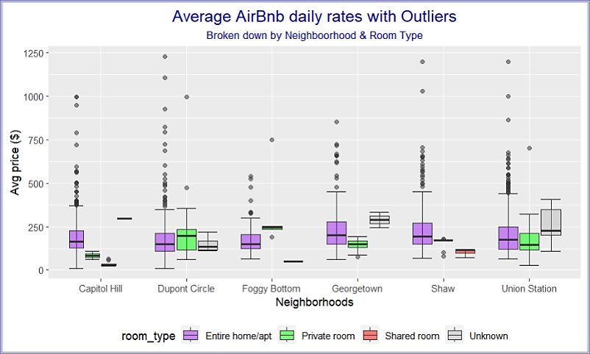
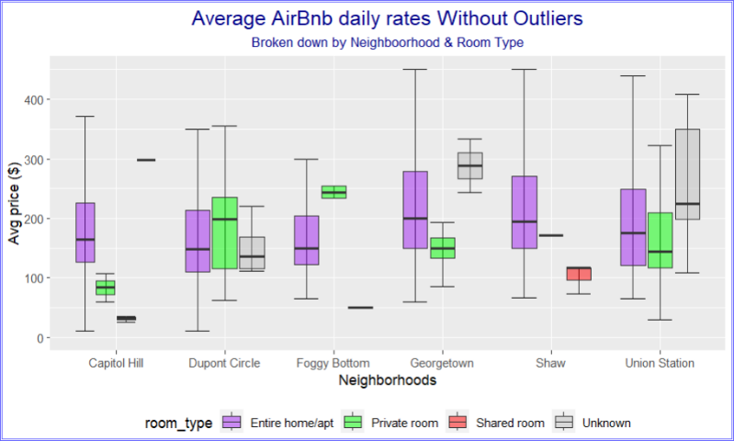
Based on table titled “Average_Price_Table” I note the following:
- Highest average price was observed at Foggy Bottom for private room at $334/ night.
- Lowest average price was observed at Capitol Hill for shared room at $35.08 / night.
To analyze variability, a box plot as displayed on Figure 2 shows average price(y-axis) by neighborhood (x-axis) and room type (x-axis legend and fill color). The box plot ranges from average price between $0- $450, and outliers were removed (price > $450) to better see variability.
- Highest price variability was observed (with outliers) is Dupont entire home/ apt with variability of $1,218 (min: 10; max 1,228)
Figure 2: Airbnb rates by Neighborhood and room type
- Highest price variability (without outliers), show that Georgetown Entire home/ apt at the $390 (min: 60, max: 450)
- Regardless of outliers or not, the lowest price variability was observed at Foggy Bottom unknown room type at a single listing of $50.

3. Compute and report a 90% confidence interval for the proportion of superhosts in the population using the available sample. Provide an interpretation of the computed confidence interval.
It was noted that 733 out of 1,718 listings were superhosts listings, attributing to approximately 42.66% proportion of the population and a standard deviation of 0.012. Using a confidence interval of 90%, the probability of superhosts within the Washington DC neighborhood would range between 40.7% to 44.7%.
- Interpretation: This primarily means that we can be confident that for 90% of the time, while superhosts
are not prevalent in the DC, they account for approximately 40.7% to 44.7% of Airbnb listings.

4. Compute and report a 95% confidence interval for the average price of the population using the available sample. Provide an interpretation of the computed confidence interval.
An analysis of average daily rates for Airbnb listings was $204.84. Based on a 95% confidence interval, I find that the average price ranges from $198.34 (lower range) to $211.34 (higher range). This explains that the value of the true population mean (95% of the time) will fall within this price range for Airbnb Washington DC neighborhood.

5. Test whether the average rating of all listings in the population is more than 4 (at 95% level of confidence).
For our test, I used a one-sample t-test: the null hypothesis was set as average rating = 4, with alternate hypothesis as average rating > 4; the implications of which meant that if I rejected the null hypothesis, then the population average rating was likely greater than 4.
The results from our t-test revealed that in order for the null hypothesis (that the population avg rating = 4) to be true, the probability of it occurring would be near zero (p-value < 2.2e^-16 to be exact) based on our sample data. Therefore, I reject the null hypothesis and accept that the alternative hypothesis (that the population avg rating is greater than 4) is likely true. Furthermore, the 95% confidence interval for the sample indicated an avg rating range of 4.69 – infinity (effectively 5 in this case), indicating that only 5% of data points fell below the 4.69 rating mark.
Figure 3 Highest correlation with price

 | Correlation test | Output
1 | Price~Accomodates | 0.5872
2 | Price~Bedrooms | 0.5373
6. What are the top two highly correlated variables with price?
I analyzed the correlation of price (dependent value) with individual independent values comprised of: minimum # of nights, reviews, host number of listings, host acceptance rate, listing ID, number of beds, number of bedrooms, and number of accommodates; and found that price had the highest correlation with number of accommodates and number of bedrooms, with correlation at 0.587 and 0.537, respectively.
What this tells us is that prices are generally higher when listings are able to accommodate higher numbers of guests and offer more bedrooms. This makes sense, as more real estate (i.e., bigger homes with more sq.ft.) is needed to accommodate more guests and provide higher numbers of bedrooms. From the Airbnb host perspective, larger properties will usually cost more in the form of property taxes, mortgages, etc., making the higher listing price a reasonable proposition from both the customer and host perspective.

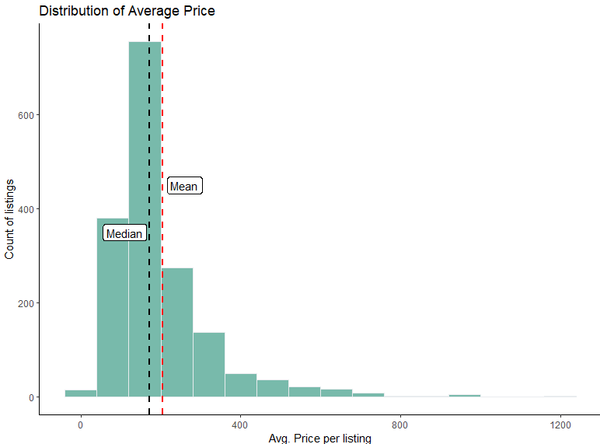
7. Visualize price to test for normality (this plot will be counted toward the total number of plots noted below).
Distribution of price is positively skewed as see on Figure 4. The median is $171 (black dashed line) and mean is $204.80 (red dashed line). The most expensive listing in the dataset has a price of $1,228 and cheapest listing has a price of $10. These listings are in Dupont Circle and Capitol Hill. Average price is highest in the Georgetown neighborhood.

Figure 4: Distribution of price

8. Implement two meaningful regression models for the “price” of the listings. Compare/present the results of the two models as a table. (Note: The point is not to build the best regression models.)
 | Model Name | Residual standard error | R² value |  | Adjusted R² value | Insight
1 | Price_Accomodates | 111.15 | 0.3448 |  | 0.3444 | Best fit model*
2 | Price_Bedrooms | 115.81 | 0.2887 |  | 0.2883
Two separate regression models were run separately: one analyzed price (dependent variable) compared to # of accommodates (independent variable) and other model analyzed price to # of bedrooms (dependent variable). Below are the results of the 2 regression models:
Figure 5: Regression models comparison

* In comparing these models, the Price_Accomodates model has the lower standard error, meaning on average, this model is $111.15 off its estimation, and like most error measures, a lower value indicates a beter fit. Additionally, the Price_Accomodates model also indicates a strong R² value and adjusted R² value as it’s closer to 1 (from a range of 0 to 1), which indicates a better overall fit. This is interprested that ~34.4% of the variance in price is explained by the acomodates variable.

